Dynamic memory allocation for Array of objects:

1)array of object:

#include<iostream>

using namespace std;

class A{

public:

int a;

A(){

a=10;

}

~A(){

cout<<"object destructed";

}

void print()

{

cout<<a<<endl;

}

};

int main()

{

A \*A1=new A;

A1->print();

delete A1;

return 0;

}

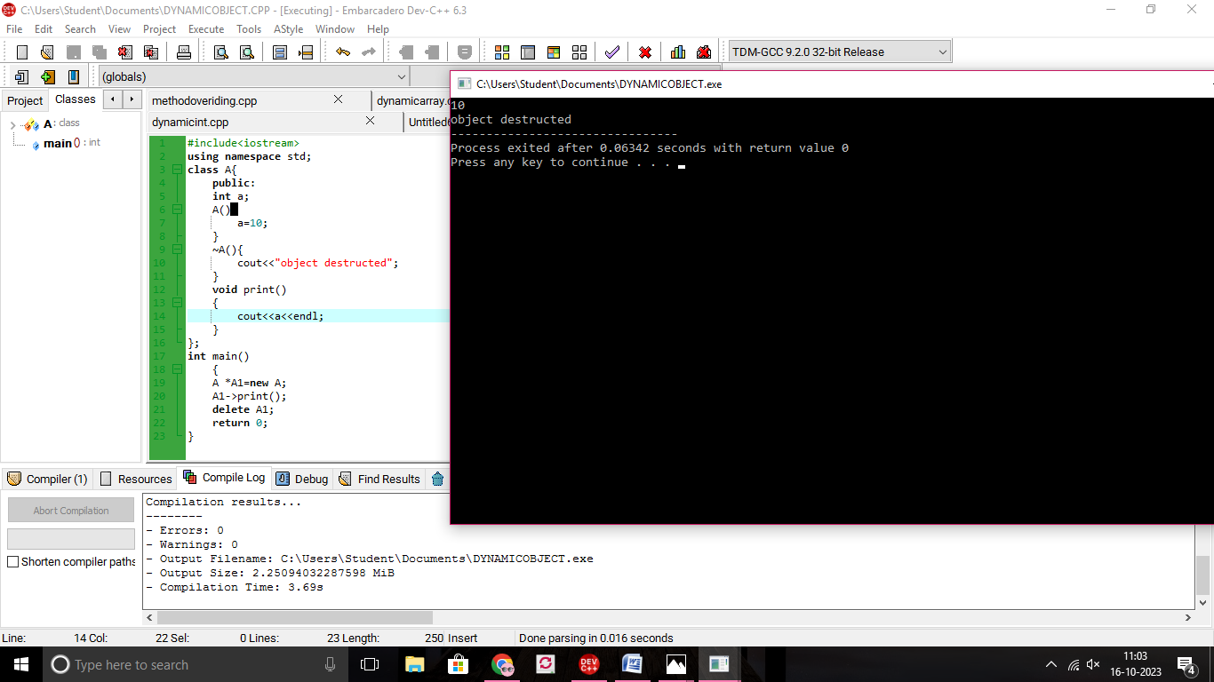

2)ARRAY OF OBJECT STATIC:

#include<iostream>

using namespace std;

class A{

public:

int a;

A(){

cout<<"enter values:";

cin>>a;

}

~A(){

cout<<"object destructed\n";

}

void print()

{

cout<<a<<endl;

}

};

int main()

{

int i;

A A1[3];

for(i=0;i<3;i++)

A1[i].print();

return 0;

}

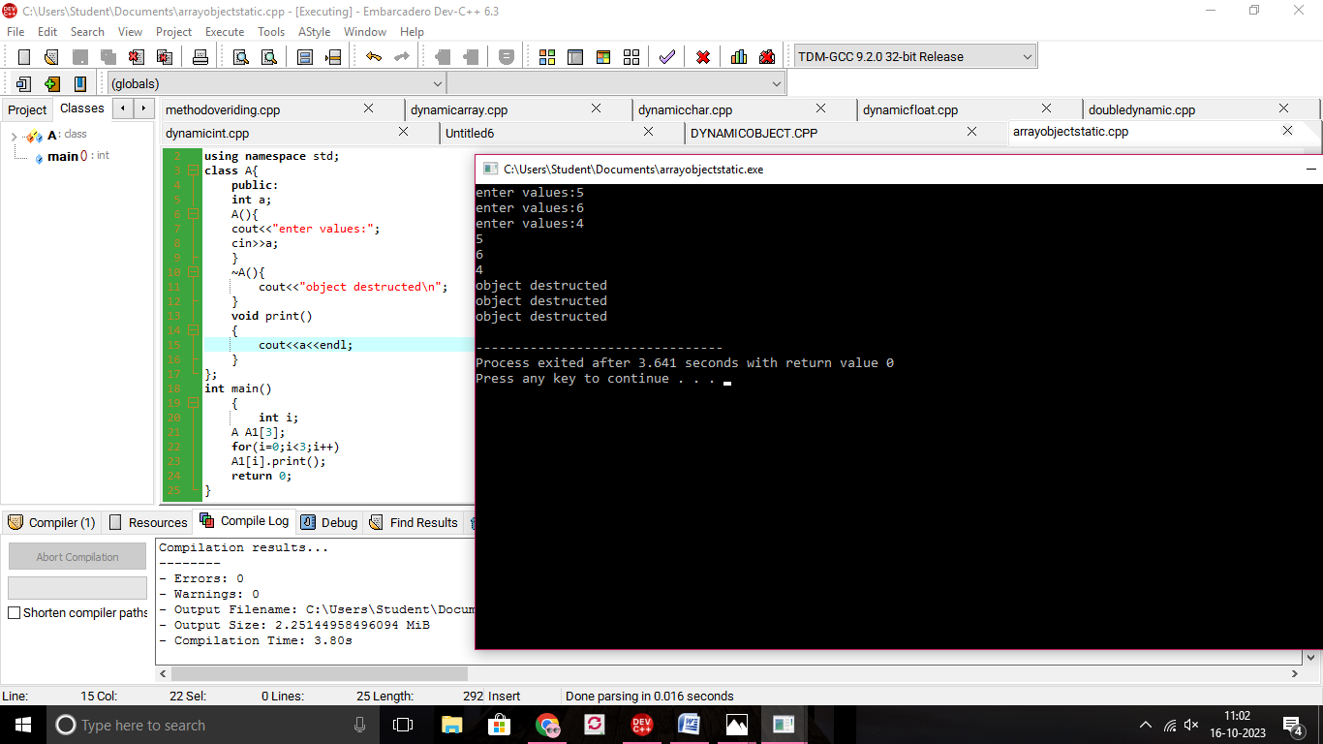

3)ARRAY OF OBJECTS FOR DYNAMIC:

#include<iostream>

using namespace std;

class A{

public:

int a;

A(){

cout<<"enter num";

cin>>a;

}

~A(){

cout<<"object destructed\n";

}

void print()

{

cout<<a<<endl;

}

};

int main(){

int i,n;

cout<<"enter value:";

cin>>n;

A \*p=new A[n];

for(i=0;i<n;i++)

{

(p+i)->print();

}

delete []p;

}

